Lesson 4 : Percentages II (A)
Answer

Checkpoint 1

The amount of rainfall of a city was 2500 mm in 2019. The amount of rainfall in 2020 was increased by 12%, and in 2021, it was decreased by 15%. Find the amount of rainfall in 2021.
$∴\text{ The amount of rainfall in} \text{2021}$,
$$2200 (1+12\%) (1-15\%)$$
=2094.4 mm

Rainfall $(mm)$
2019 | $$2500$$
2020 | $$2500 (1+12\%)$$
2021 | $$2500 (1+12\%) (1-15\%)$$

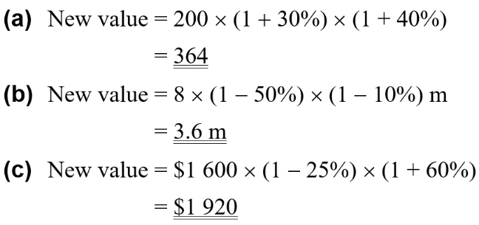
1. Find the new value in each of the following.
(a) 200 increases by 30% and then increases by 40%.
(b) 8 m decreases by 50% and then decreases by 10%.
(c) $1 600 decreases by 25% and then increases by 60%.

2. The amount of rainfall of a city was 2 200 mm in 2010. The amount of rainfall in 2011 was decreased by 18%, and in 2012, it was increased by 2%. Find the amount of rainfall in 2012.

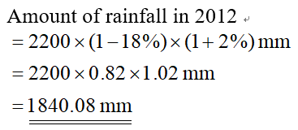

3. There are 200 books on a bookshelf, of which 60% are fiction and the rest are non-fiction. If the numbers of fiction and non-fiction books are increased by 10% and 20% respectively, find
(a) the number of fiction books now,
(b) the number of non-fiction books now,
(c) the increase in the number of books on the bookshelf.

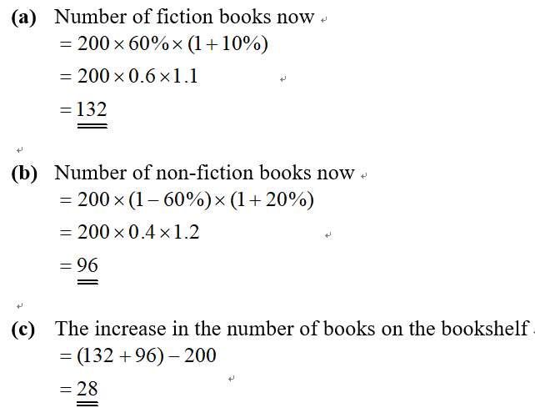



Checkpoint 2

Tony’s monthly salary was increased by $4\%$ and $3.5\%$ in last two years respectively. If Tony’s monthly salary is $\$13 455$ in 2020 , find his monthly salary $2$ years ago (i.e. in 2018).

Salary $(\$)$
2018 | $$x$$
2019 | $$x (1+4\%)$$
2020 | $x (1+4\%) (1+3.5\%)$=$13 455

4. A table is worth $697 now. Its current value is 18% lower than that of last year. Last year, its value was 15% lower than that of 2 years ago. Find the value of the table 2 years ago.

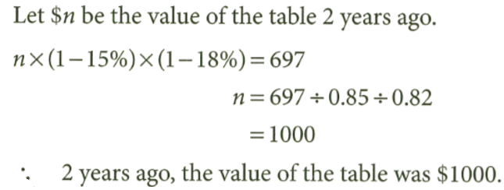

5. When a number is first increased by 15% and then decreased by 30%, the result is 241.5. What is the original value of the number?
50. $x^{4}-2x^{2}+1$

49. $x^{4}-1$

$$y×\left(1+15\%\right)×\left(1-30\%\right)=241.5$$
$y=300$

6. If a number is increased by 25% and then decreased by 10%, it becomes 99. Find the original number.
$$y×\left(1+25\%\right)×\left(1-10\%\right)=99$$
$y=88$

7. The monthly salary of Mr. Lee was increased by 12% and 25% in the last two years. If his current monthly salary is $17 500, what was his monthly salary two years ago?

$$x×\left(1+12\%\right)×\left(1+25\%\right)=17 500$$
$$x = 12 500$$

8. Find the original value in each of the following.
(a) After increasing by 6% and then increasing by 7%, the new value is 90 736.
(b) After increasing by 30% and then decreasing by 20%, the new value is 208 g.
(c) After decreasing by 40% and then increasing by 60%, the new value is 76.8 cm³.

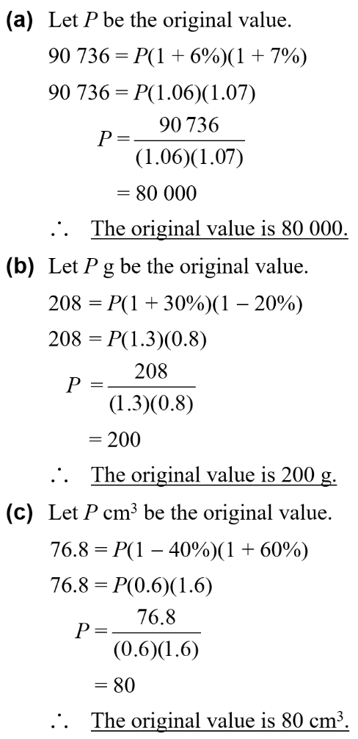



9. The price of a car is $125 000. The price is first decreased by 15% and then further decreased by 8%. Find the overall percentage change in the price of the car.

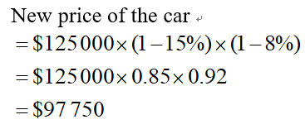
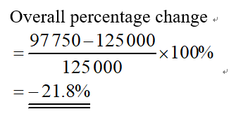

Recall:
$$Percentage change=\frac{new-old}{old}×100\%$$

10. The volume of water in the container is 1.25L. The volume is first increased by 22% and then further decreased by 30%. Find the overall percentage change in the volume of water.

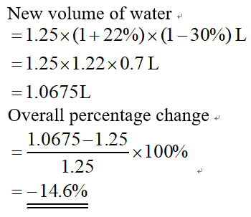

11. The tax revenue of a government increased by 20%, 10%, 35% respectively in the first three quarters of 2021, and then decreased by 45% in the fourth quarter of the year. What was the overall percentage change in the quarterly tax revenue over the whole year 2021?

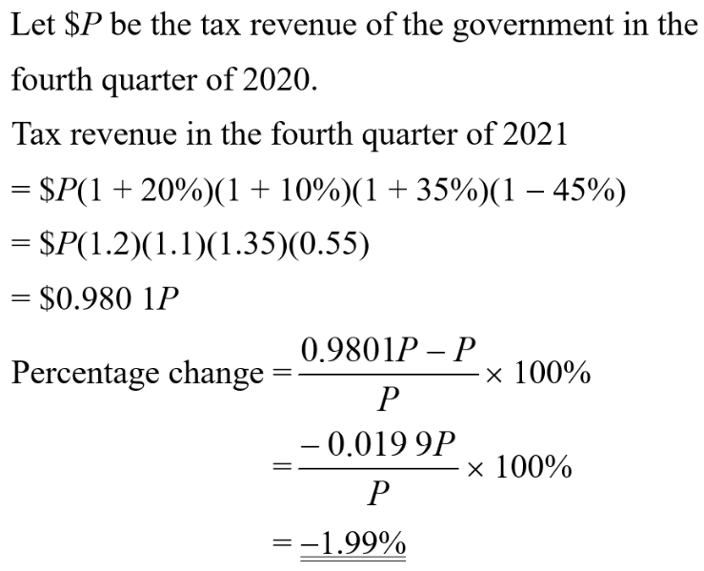
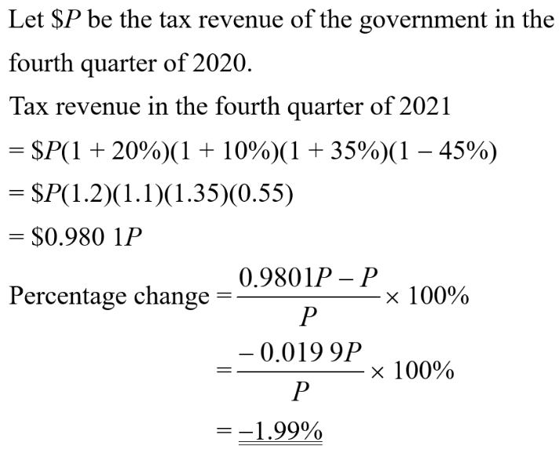

12. If a number is decreased by 90% and then increased by x%, the overall percentage change is −83%. Find x.
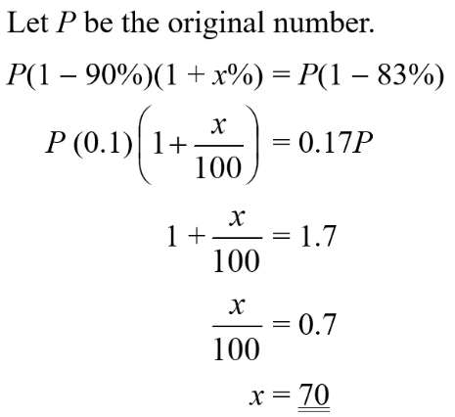

13. The length, the width and the height of a rectangular block are 15 cm, 8 cm, and 18 cm respectively. If the length increases by 20% and the width increases by 15%, but the volume decreases by 10%, find the percentage change in height.

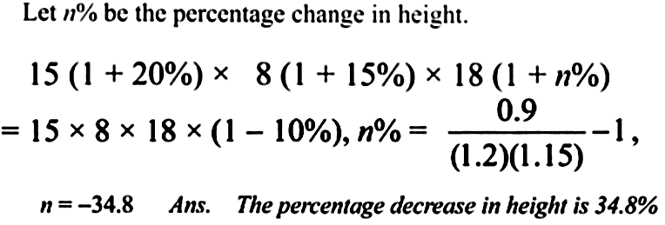

14. The length, the width and the height of a rectangular block are 10 cm, 15 cm, and 21 cm respectively. If the length decreases by 15% and the width increases by 16%, but the volume increases by 6%, find the percentage change in height.

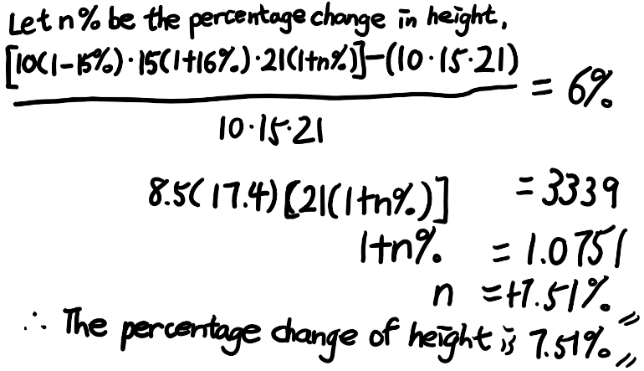

15. The radius r cm of a circle is decreased by 20%.
(a) Express the original area of the circle in terms of r.
(b) Express the new area of the circle in terms of r.
(c) Find the percentage change in the area of the circle.

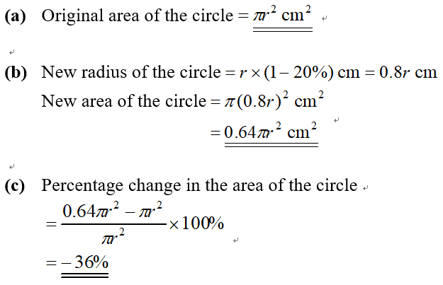
Hints:
$$\frac{3x-x}{x} \frac{3x^{2}-x^{2}}{x^{2}}$$
=$\frac{2x}{x} =\frac{2x^{2}}{x^{2}}$
=2 = 2

16. The length of a square is l cm. If the length is first increased by 20% and then further increased by 20%,
(a) express the new area of the square in terms of l,
(b) find the percentage change in the area of the square.

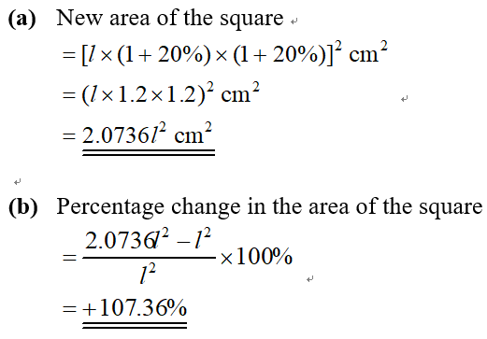


17. Evelyn’s pocket money was increased by 10% last month, but is decreased by 10% this month. What is the overall percentage change of her pocket money?
[Hint: Let $x be Evelyn’s original pocket money.]

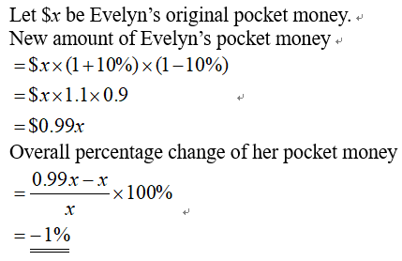

18. The length and the width of a rectangle are l cm and w cm respectively. If the length is increased by 10% and the width is decreased by 30%,
(a) express the new area of the rectangle in terms of l and w,
(b) find the percentage change in the area of the rectangle.

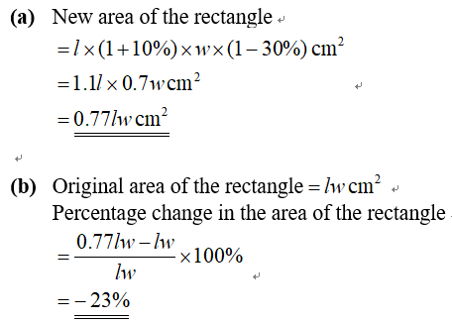

19. The angle of a sector is decreased by 20% but its radius is increased by k%. If the arc length of the sector remains unchanged, find the value of k.

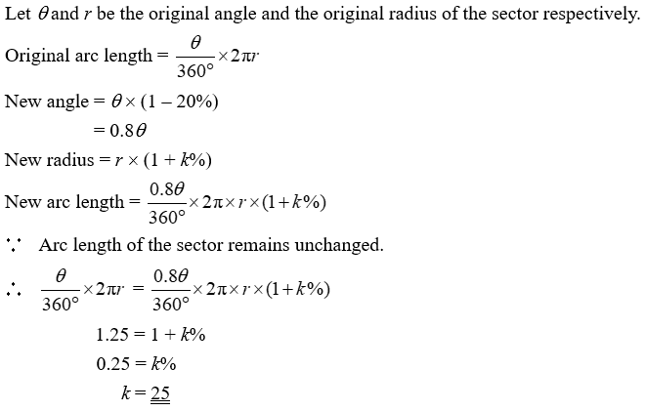

20. In a normal day, Helen spends 37.5% of the time sleeping and 10% of the remaining time studying.
(a) What is the amount of time used for other purposes in a normal day?
(b) An examination is approaching, so Helen has to spend more time on studying. She has decided to reduce the sleeping time and other purposes by 5% respectively.
(i) Find the percentage change in Helen’s studying time.
(ii) Furthermore, she increases the reading speed by 4%. Find the percentage increase in the amount of reading materials she can read.

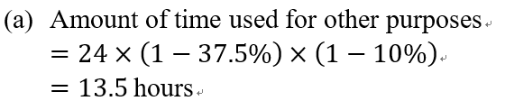
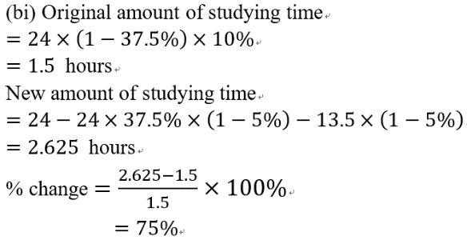
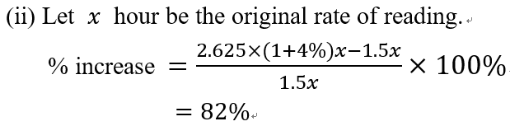

21. The operating cost of a company is composed of three parts:
Advertising $10 000 Rent $40 000 Wage $200 000
If the advertising cost increases by 10%, the rent decreases by 20% and the wage increases
by 5%, find the percentage change in the operating cost of the company.

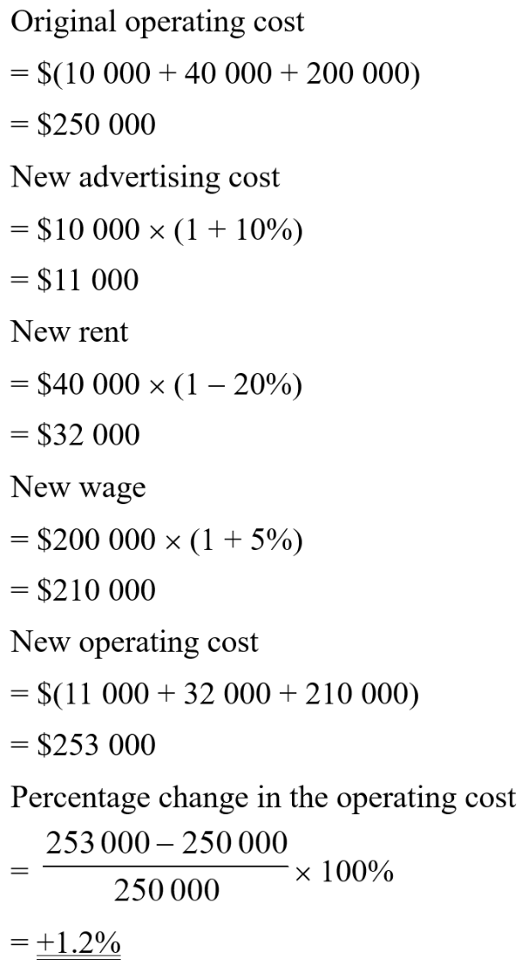
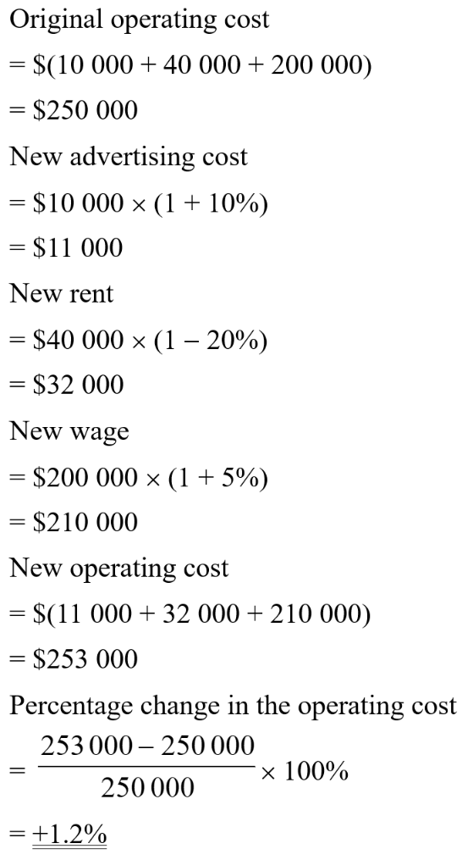

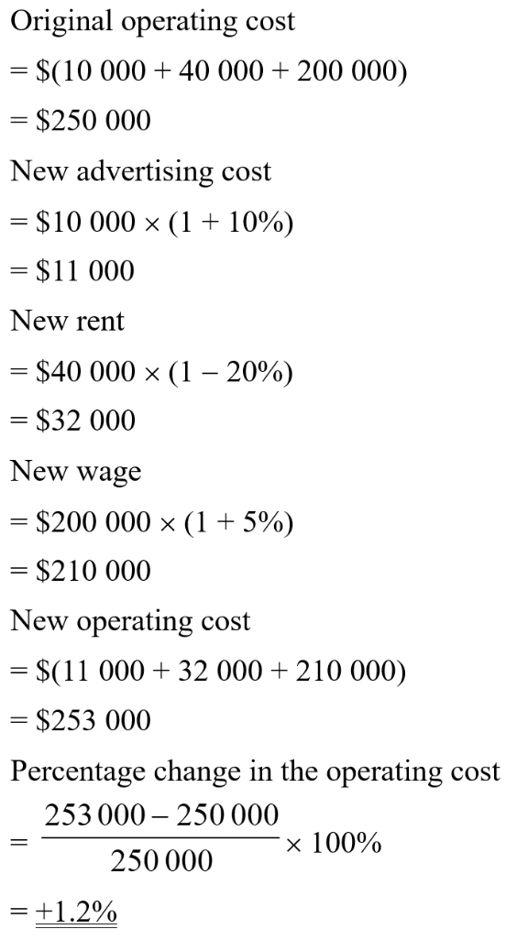

22. Last week, the number of books sold in bookstores P, Q and R were 150, 240 and 320 respectively. As compared to last week, the number of books sold this week in bookstore P decreases by 2%, that in bookstore Q increases by 5% and that in bookstore R remains unchanged. Find the percentage change in the total number of books sold in the three bookstores, correct to 3 significant figures.

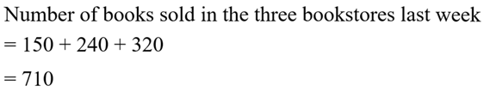

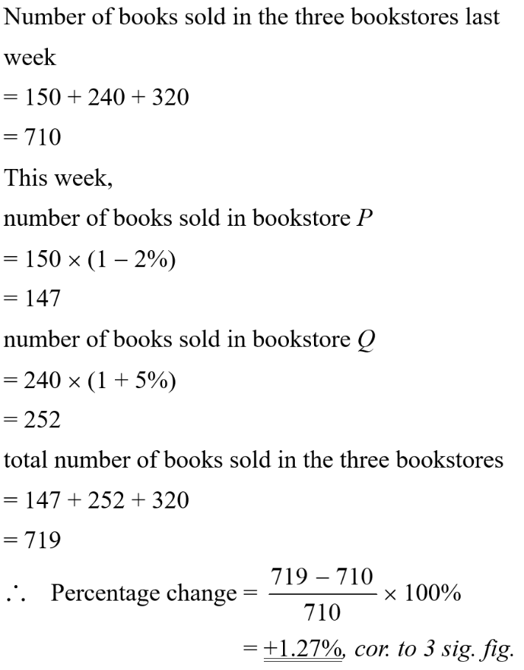
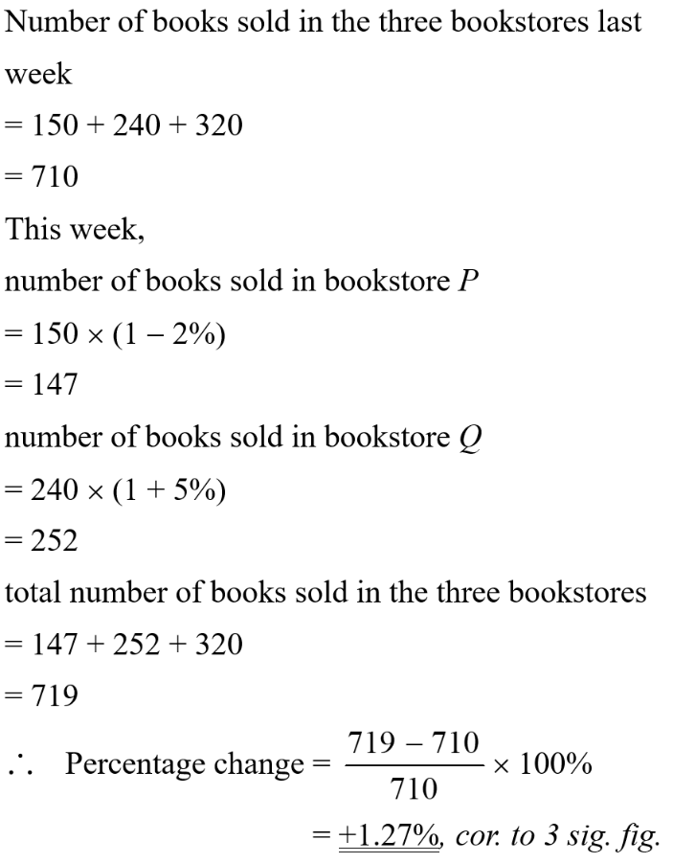



23. Last week, the numbers of male customers and the female customers in a shopping mall were in the ratio 1 : 3. This week, the number of male customers increases by 16% while the number of female customers decreases by 12%. Is there an increase in the total number of customers as compared to last week? Explain your answer.

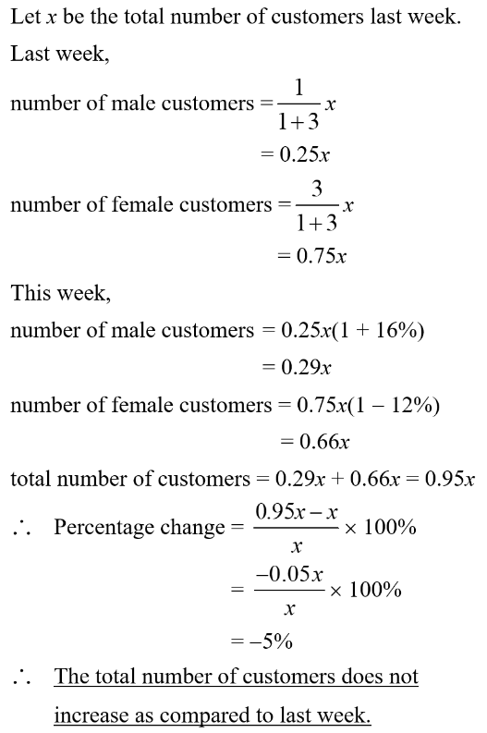

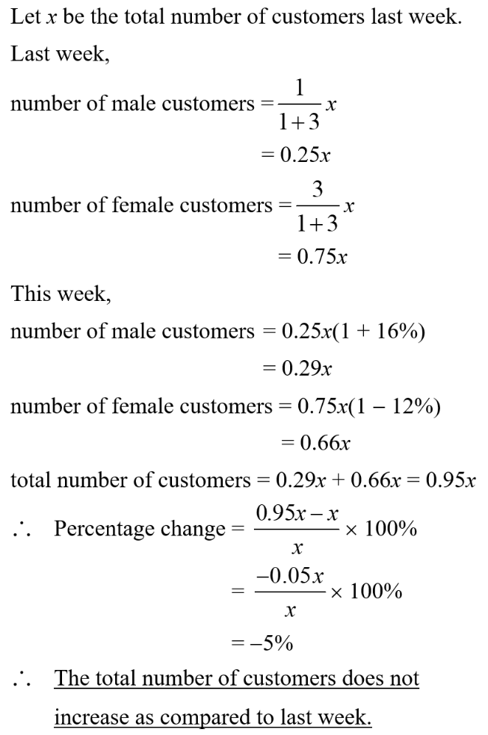

24. The numbers of tourists of three cities A, B and C in 2020 are listed below:
City | A | B | C
Number of tourists | 2 500 | 900 | 1 600
In 2021, the numbers of tourists of cities B and C increased by 40% and 20% respectively. If the total number of tourists of the three cities increased by 4%, find the percentage change in the number of tourists of city A.

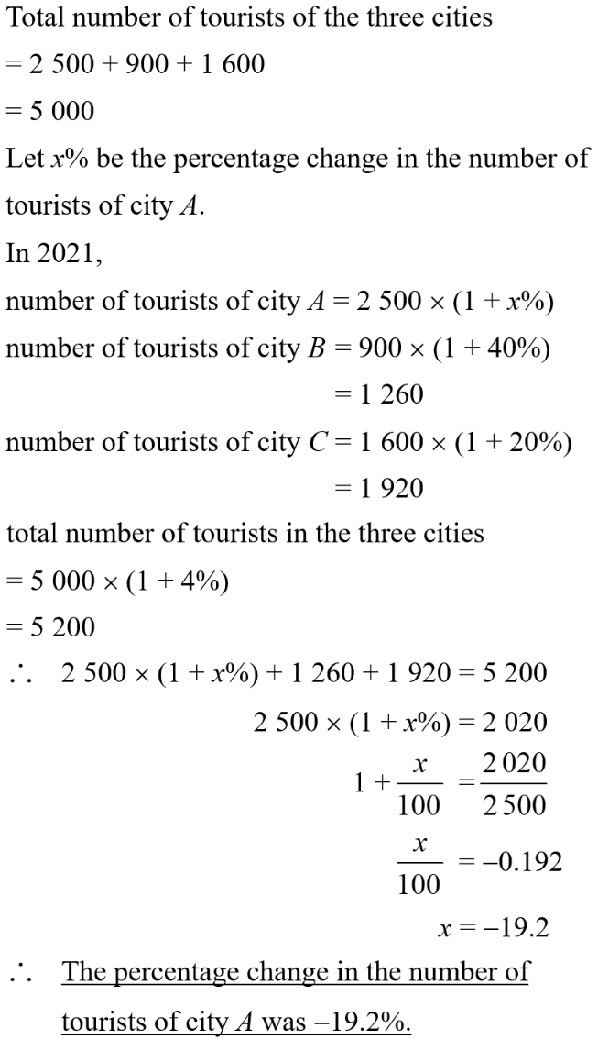
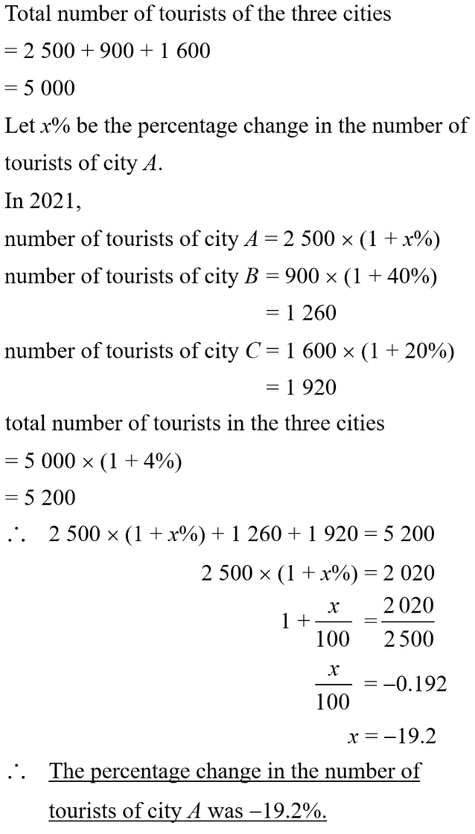

25. There are some apples, oranges and peaches in a box. The numbers of apples, oranges and peaches are in the ratio 2 : 5 : 3. If the number of apples decreases by 40%, the number of oranges increases by 15% and the number of peaches decreases by 5%, find the percentage change in the number of fruits in the box.

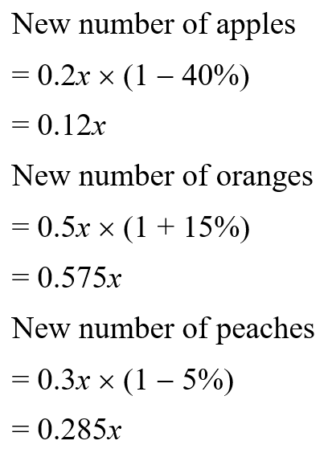
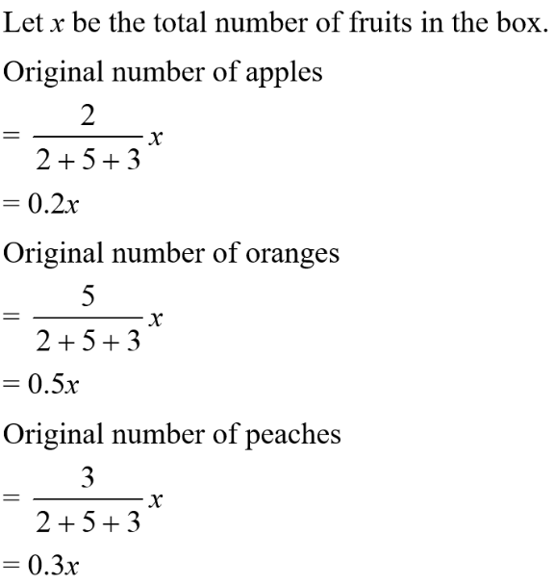

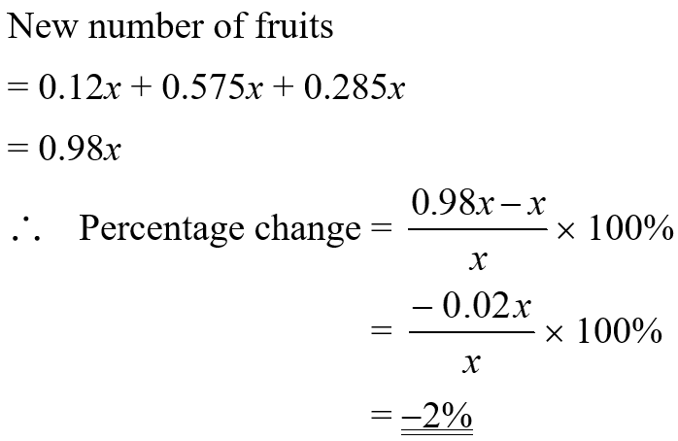


26. If the height of a right cylinder increases by 60% and its curved surface area remains unchanged, find the percentage change in the volume of the cylinder.

